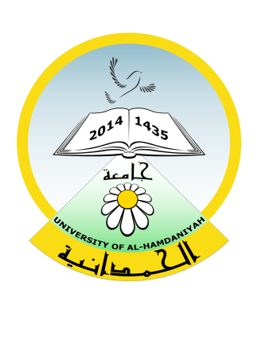

Republic of Iraq
Ministry of Higher Education and Scientific Research
University of Al-Hamdaniya
University Health Unit

جمهورية العراق
وزارة التعليم العالي والبحث العلمي
جامعة الحمدانية
وحدة الصحة الجامعية

Email/University Presidency Email: hamdaniyahuniversity@gmail.com

No. Date: / /2024
To/Bartella General Hospital
Affair/Referring
Greetings,
We refer to you Mr./Mrs. ( ), an employee at our university who holds the position of ( ), to kindly diagnose his/her medical condition, provide the appropriate treatment, and inform us of the result so that we can take the required measure ....... With appreciation.
Result:

Attending Physician

Attending Physician

University Health Unit

Section Administrator
/ /2024
A copy thereof to/
- University Health Unit/Health File
- HR
- Outbox

