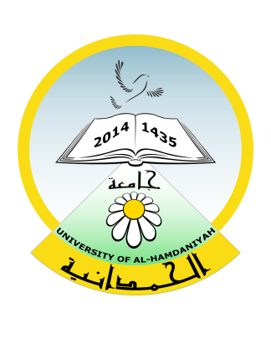

Republic of Iraq
Ministry of Higher Education and Scientific Research
University of Al-Hamdaniya
University Health Unit

جمهورية العراق
وزارة التعليم العالي والبحث العلمي
جامعة الحمدانية
وحدة الصحة الجامعية

E-mail health@uohamdaniya.edu.iq

No. Date: / /2024
To/Bartella General Hospital
Affair/Leave

Greetings,
Kindly examine and treat the student ( ) at the College ( (, and inform us to take the necessary action on our part.

Result:

Attending Physician

University Health Unit

